City of East Chicago
“a city of hope & progress”


Subrecipient Handbook


Community Development Block Grant

Responsible Entity
City of East Chicago Department of Redevelopment
4525 Indianapolis Blvd.
East Chicago, Indiana 46312
Phone: 219.391.8513 ~ Fax: 219.391.7005
https://www.eastchicago.com/243/Redevelopment

Anthony Copeland, Mayor


Frank Rivera, Executive Director

Last Updated: October 2021
Table of Contents

ACRONYMS 1
A MESSAGE TO CDBG SUBRECIPIENTS 2
SUBRECIPIENT RESPONSIBILITIES 3
CDBG PROGRAM OVERVIEW 3
ELIGIBLE ACTIVITIES 4
NATIONAL OBJECTIVES COMPLIANCE 5
Suspension and debarment 12
E-VERIFY PROGRAM 12
CONFLICT OF INTEREST 13
ENVIRONMENTAL REVIEW 13
PROCUREMENT 14
Other Federal Requirements 15
FINANCIAL MANAGEMENT 16
PAYMENT REQUEST PROCEDURE 17
DOCUMENTATION AND REPORTING REQUIREMENTS 18
MONITORING 21
CLOSEOUT OF GRANT 22
TECHNICAL ASSISTANCE 22
APPENDIX A: SELF CERTIFICATION FORM / HUD INCOME LIMITS 23
APPENDIX B: 2 CFR §200.112 CONFLICT OF INTEREST 25
APPENDIX C: SUSPENSION AND DEBARMENT 27
APPENDIX D: E-VERIFY AFFIDAVIT 28
APPENDIX E: RESOLUTION NO. 2013-04 30
APPENDIX F: BUSINESS ENTITY REPORT 32

ACRONYMS

AAP – Annual Action Plan
ADA – American with Disabilities Act
AI – Analysis of Impediments to Fair Housing
CAPER – Consolidated Annual Performance Evaluation Report
CBDO – Community-Based Development Organization
CDBG – Community Development Block Grant
CDFI – Community Development Financial Institutions
CFR – Code of Federal Regulations
CHDO – Community Housing Development Organization
ConPlan – Consolidated Plan
CPP – Citizen Participation Plan
CPR – Certified Payroll Report
DBRA – Davis Bacon and Related Acts
DOL – Department of Labor
FEMA – Federal Emergency Management Agency
FFATA – Federal Funding Accountability and Transparency Act
FSRS – Federal Funding Accountability and Transparency Act Subaward Reporting System
FHEO – Fair Housing and Equal Opportunity
FLSA – Fair Labor Standards Act
FONSI – Finding of No Significant Impact
HUD – U.S. Department of Housing and Urban Development
IDIS – Integrated Disbursement & Information System
LMA – Low to moderate income area
LMC – Low to moderate income clientele
LMH – Low to moderate income households
MBE – Minority-Owned Business Enterprise
NOFA – Notice of Funding Availability
OMB – Office of Management and Budget
PI – Program Income
RFP – Request for Proposals
RLF – Revolving Loan Fund
RROF – Request for Release of Funds
UFAS – Uniform Federal Accessibility Standards
URA – Uniform Relocation Assistance and Real Property Acquisition Policies Act of 1970
WBE – Woman-Owned Business Enterprise

A MESSAGE TO CDBG SUBRECIPIENTS

As Community Development Block Grant (CDBG) subrecipients, you are a fundamental part of the CDBG Entitlement program. You provide grantees and the U.S. Department of Housing and Urban Development (HUD) with assurance that the diverse communities, groups, and individuals whom the CDBG program is intended to serve are in fact reached by the program. Your participation provides:
- Access to, and knowledge of, the specific neighborhoods and beneficiaries served by the program;
- Technical and managerial capabilities that might not otherwise be available to grantees; and
- A mechanism for assuring citizen participation by involving the intended beneficiaries in the design and delivery of those services.
Without your continued involvement and support, the CDBG program could not address the broad range of needs in our communities. Whether you are a governmental agency or a non-profit organization, HUD and the City of East Chicago count on you to make sure that needed services are delivered in a cost-effective way. This is not an easy task. Despite numerous accomplishments in program delivery, many of you have encountered administrative problems in achieving your mission, hence, the motive for this handbook.

SUBRECIPIENT RESPONSIBILITIES

Grantees and Subrecipients share joint responsibility for carrying out permitted activities in conformance with applicable Federal requirements. A central principle is that most of the Federal requirements imposed on the City of East Chicago, as a grantee, are passed along to you, the subrecipient. The more you, as a subrecipient, know about the rules, the more efficient you can be in designing and conducting your programs.
Regulatory compliance and performance go hand-in-hand. Performance measurement is an effective management technique that enables grantees to analyze the benefits of their investments. It is a mechanism that tracks the progression of projects and evaluates their overall program effectiveness. The CDBG program requires that each grantee submit a performance and evaluation report concerning the use of CDBG funds, together with an assessment of the relationship of the use of funds to the objectives identified in the City of East Chicago’s Consolidated Plan. Subrecipients should also establish goals and measure their performance in a manner consistent with the grantee’s performance measurement system.
In using Federal funds the cardinal rule is: documentation. The achievement of program goals and the completion of activities must be supported by adequate documentation of the facts. If your activities, personnel, procedures, expenditures, and results are not documented properly, from the Federal Government’s perspective, you have not done your job, regardless of your accomplishments. Appropriate records are the lifeblood of all successful CDBG subrecipients.

CDBG PROGRAM OVERVIEW

The Community Development Program was established to address local housing and community development needs. Funds are provided through the Community Development Block Grant (CDBG) program. First created by Congress in 1974, block grant funds are provided by the U.S. Department of Housing and Urban Development (HUD) and are used to support a wide range of housing and community development initiatives. The purpose of the CDBG program is to develop and support healthy communities by providing housing and economic development opportunities that support and serve East Chicago residents earning very low to moderate incomes throughout the City.
The CDBG program provides uniquely flexible resources for community development. The City of East Chicago is an entitlement city, which means it receives an annual allocation of CDBG funds directly from the U.S. Department of Housing and Urban Development (HUD). The City is utilizing these funds to help build and strengthen our community, particularly those neighborhoods with a high number of residents living in poverty. The intent of the CDBG program is to support efforts that improve the quality of life for low and moderate-income persons.
The Department of Redevelopment has been designated to administer the CDBG programs approved under the City’s 2019-2023 Consolidated Plan and its on-going Annual Action Plans. Redevelopment works with other departments to ensure that all City related policies and procedures are also followed. One of the goals of the Department of Redevelopment is to use the CDBG funding while meeting the national objectives to develop viable urban communities through the provision of decent housing and a suitable living environment, and by expanding economic opportunities, principally for low- and moderate-income persons. Redevelopment ensures that the CDBG funds are utilized to develop and preserve affordable housing, improves the local environment, rehabilitates community facilities and offers programs and services to improve the life of low and moderate income residents in East Chicago.
Redevelopment guides and coordinates the City’s CDBG program and administers a variety of projects/programs with non-profit and for-profit organizations {sub-grantees, subrecipients and/or contractor and sub-contractors} to meet the City’s goal to strengthen the social, physical and economic infrastructure of East Chicago’s low and moderate-income neighborhood and community needs.
This handbook is intended to provide information for use by subrecipients in the management of their CDBG projects/programs. Information in this handbook has been simplified and updated to reflect the latest changes in Federal regulations and the City of East Chicago policies. If a subrecipient is unsure how to proceed after reading this handbook, they are encouraged to call the Department of Redevelopment at (219)391-8513.

ELIGIBLE ACTIVITIES

CDBG funds are intended to create and foster viable urban communities by providing decent housing and suitable living environments and through the expansion of economic opportunities for low and moderate-income persons. The City of East Chicago seeks to maximize the benefits of these funds by partnering with local organizations to conduct eligible activities.

To utilize CDBG funds for a public service, the service must be either:
- A new service; or
- A quantifiable increase in the level of an existing service which has been provided by the grantee or another entity on its behalf through State or local government funds in the 12 months preceding the submission of the grantee’s Consolidated Plan Annual Action Plan to HUD.

An exception to this requirement may be made if HUD determines that any decrease in the level of a service was the result of events not within the control of the local government.

Specifically, the public services provision applies in the following manner:
- If a service is new, it may be funded; or
- If a service is existing, determine whether it was provided by or on behalf of the unit of local government with local or state funding; or
- If it was not provided by or on behalf of the local government with funding from the local government, it may be funded; or
- If it was provided by or on behalf of the local government with funding from the State or local government, grantees must determine whether the proposed service will be a quantifiable increase in the level of service. If it can be documented that the service is a quantifiable increase in the level of service, it may be funded; or
- The regulations do not prohibit a grantee from continuing to provide funding to a CDBG funded public service at the same or decreased level in subsequent program years.

NATIONAL OBJECTIVES COMPLIANCE

CDBG regulations require that all activities meet at least one of three national objectives. A national objective is considered to be met ONLY if it can be determined and documented that the program:

- Provides direct benefit to low and moderate-income persons:
  - Area Benefit Activities – Available to all the residents in a particular area, where at least 51% of the residents are low and moderate-income persons
  - Limited Client Activities – Benefits limited clients, at least 51% of whom are low and moderate-income persons
  - Housing Activities – Activity carried out for the purpose of providing or improving permanent resident structures which, upon completion, will be occupied by low and moderate-income persons.
  - Job Creation or Retention Activities – Designed to create or retain permanent jobs where at least 70% of the jobs, computed on a full-time equivalent basis, involve the employment of low and moderate-income persons.

- Prevention or Elimination of Slum or Blight:
  - Activities on an Area Basis – Activity addresses one or more conditions that contribute to the deterioration of a specific area that meets the definition of slum and blight and has one or more buildings deteriorating
  - Spot Basis Activity – Eliminate specific conditions of blight or physical decay on a spot basis located in a slum or blighted area, which meet this objective

- Urgent Need:
  - Eliminate conditions that threaten the health and welfare of the community or address conditions that recently occurred. Reserved for natural disasters and extraordinary circumstances.

CDBG MATRIX CODES: PUBLIC SERVICES
INDEX CODE | TITLE
05A | Senior Services 24 CFR 570.201(e) or 42 USC 5305(a)(8) + 24 CFR 570.482(c)(2)  Services for the elderly. 05A may be used for an activity that serves both the elderly and persons with disabilities provided it is intended primarily to serve elderly. If the activity is intended primarily to serve persons with disabilities, use 05B instead.
05B | Services for Persons with Disabilities 24 CFR 570.201(e) or 42 USC 5305(a)(8) + 24 CFR 570.482(c)(2)  Services for the persons with disabilities, regardless of age. If the activity is intended primarily for elderly persons, use 05A instead.
05C | Legal Services 24 CFR 570.201(e) or 42 USC 5305(a)(8) + 24 CFR 570.482(c)(2)  Services providing legal aid to low- and moderate-income (LMI) persons. If the legal service is only provided for the settlement of tenant/landlord disputes, use 05K.
05D | Youth Services 24 CFR 570.201(e) or 42 USC 5305(a)(8) + 24 CFR 570.482(c)(2)  Services for young people age 13 to 19. For example, recreational services limited to teenagers and teen counseling programs. 05D can also be used for counseling programs that target teens but include counseling for the family as well. For services for children age 12 and under, use 05L; for services for abused and neglected children, use 05N.
05E | Transportation Services 24 CFR 570.201(e) or 42 USC 5305(a)(8) + 24 CFR 570.482(c)(2)  General transportation services. Transportation services for a specific client group should use the matrix code for that client group. For example, use 05A for transportation services for the elderly.
05F | Substance Abuse Services 24 CFR 570.201(e) or 42 USC 5305(a)(8) + 24 CFR 570.482(c)(2) Substance abuse recovery programs and substance abuse prevention/education activities. If the services are provided for a specific client group, the matrix code for that client group may be used instead. For example, substance abuse services that target teenagers may be coded either 05D or 05F.
05G | Services for victims of domestic violence, dating violence, sexual assault or stalking 24 CFR 570.201(e) or 42 USC 5305(a)(8) + 24 CFR 570.482(c)(2)  Services for victims of domestic violence, dating violence, sexual assault or stalking. For services limited to abused and neglected children, use 05N.
05H | Employment Training 24 CFR 570.201(e) or 42 USC 5305(a)(8) + 24 CFR 570.482(c)(2)  Assistance to increase self-sufficiency, including literacy, independent living skills, resume writing, job coaching, “how to get and keep a job” training, or training students in a particular field on skill when there is no tie to a specific position or business. For activities providing training for specific permanent jobs with specific businesses, use 18A.
05I | Crime Awareness/Prevention 24 CFR 570.201(e) or 42 USC 5305(a)(8) + 24 CFR 570.482(c)(2) Promotion of crime awareness and prevention, including crime prevention education programs, community-oriented policing programs above and beyond normal staffing levels, installation of security cameras, and paying for security guards.
05J | Fair Housing Activities (subject to Public Services cap) 24 CFR 570.201(e) or 42 USC 5305(a)(8) + 24 CFR 570.482(c)(2)  Fair housing services (e.g. counseling on housing discrimination) as public services. The activity needs to meet a national objective. For fair housing services activities carried out as part of general program administration (and thus not required to meet a national objective), use 21D.
05K | Tenant/Landlord Counseling 24 CFR 570.201(e) or 42 USC 5305(a)(8) + 24 CFR 570.482(c)(2) Counseling to help prevent or settle disputes between tenants and landlords.
05L | Child Care Services 24 CFR 570.201(e) or 42 USC 5305(a)(8) + 24 CFR 570.482(c)(2)  Services that will benefit children (generally under age 13), including parenting skills classes. For services exclusively for abused and neglected children, use 05N.
05M | Health Services 24 CFR 570.201(e) or 42 USC 5305(a)(8) + 24 CFR 570.482(c)(2)  Services addressing the physical health needs of residents of the community. For mental health services, use 05O.
05N | Services for Abused and Neglected Children 24 CFR 570.201(e) or 42 USC 5305(a)(8) + 24 CFR 570.482(c)(2)  Daycare and other services exclusively for abused and neglected children.
05O | Mental Health Services 24 CFR 570.201(e) or 42 USC 5305(a)(8) + 24 CFR 570.482(c)(2)  Services addressing the mental health needs of residents of the community.
05P | Screening for Lead Poisoning 24 CFR 570.201(e) or 42 USC 5305(a)(8) + 24 CFR 570.482(c)(2) Activities undertaken primarily to provide screening for lead poisoning.  Note:  - Use 05P to test people for possible lead poising.  - Use 14I to test buildings/properties for presence of lead contamination.
05Q | Subsistence Payments 24 CFR 570.207(b)(4) or 42 USC 5305(a)(8) + 24 CFR 570.482(c)(2) One-time or short-term (no more than three months) emergency payments on behalf of individuals or families, generally for the purpose of preventing homelessness. Examples include utility payments to prevent cutoff of service, and rent/mortgage payments to prevent eviction.
05R | Homebuyer Downpayment Assistance - Excluding Housing Counseling under 24 CFR 5.100 24 CFR 570.201(e) or 42 USC 5305(a)(8) + 24 CFR 570.482(c)(2)  Homebuyer downpayment assistance provided as a PUBLIC SERVICE. If housing counseling (under 24 CFR 5.100) is provided to in conjunction with downpayment assistance, report housing counseling separately under matrix code 05Y. If referral services, homeownership education programs, or general budget/financial counseling are provided to homebuyers in conjunction with downpayment assistance as part of a package, then the services are considered activity delivery costs as a part of an 05R activity.  - It is subject to the public service cap, unless the assistance is provided by a CBDO in an NRSA or by a 105(a)(15) entity.  - Only report the number of households that received downpayment assistance as accomplishments for 05R.  - For more extensive types of homeownership assistance provided under authority of the National Affordable Housing Act, use code 13B
05S | Rental Housing Subsidies 24 CFR 570.204 or 42 USC 5305(a)(8) + 24 CFR 570.482(c)(2)  Tenant subsidies exclusively for rental payments for more than three months. Activities providing this form of assistance must be carried out by CBDOs or 105(a)(15) entities.
05T | Security Deposits 24 CFR 570.201(e) or 42 USC 5305(a)(8) + 24 CFR 570.482(c)(2)  Tenant subsidies exclusively for payment of security deposits.
05U | Housing Counseling only, under 24 CFR 5.100 24 CFR 570.201(e) or 42 USC 5305(a)(8) + 24 CFR 570.482(c)(2)  Housing counseling, under 24 CFR 5.100, for renters, homeowners, and/or potential new homebuyers that is provided as an independent public service (i.e., not as part of another eligible housing activity).
05V | Neighborhood Cleanups 24 CFR 570.201(e) or 42 USC 5305(a)(8) + 24 CFR 570.482(c)(2)  One-time or short-term efforts to remove trash and debris from neighborhoods. Examples of legitimate uses of this code include neighborhood cleanup campaigns and graffiti removal.
05W | Food Banks 24 CFR 570.201(e) or 42 USC 5305(a)(8) + 24 CFR 570.482(c)(2)  Costs associated with the operation of food banks, community kitchens, and food pantries, such as staff costs, supplies, utilities, maintenance, and insurance.
05X | Housing Information and Referral Services 24 CFR 570.201(e) or 42 USC 5305(a)(8) + 24 CFR 570.482(c)(2)  An activity that provides housing information, education, and referral services, or general budget/financial counseling that does not meet the 24 CFR 5.100 definition of Housing Counseling.
05Y | Housing Counseling under 24 CFR 5.100 Supporting Homebuyer Downpayment Assistance (05R) 24 CFR 570.201(e) or 42 USC 5305(a)(8) + 24 CFR 570.482(c)(2)  Housing Counseling, under 24 CFR 5.100, that is provided to in conjunction with homebuyer downpayment assistance (05R) as a public service.
05Z | Other Public Services Not Listed in 03T and 05A-05Y 24 CFR 570.201(e) or 42 USC 5305(a)(8) + 24 CFR 570.482(c)(2)  This matrix code replaced matrix code 05. Only use this matrix code when an activity does not fall under a more specific 05A-05Y code. An example of a legitimate use of this code is when the CDBG funds are provided to a non-profit organization that provides multiple types of social services for operating costs. In another example, when a public service activity that does not have a more specific matrix code, provides services to multiple groups of clients such as seniors, persons with disabilities, and homeless persons. For instance, for a “meals on wheels” program for seniors and persons with disabilities, use 05Z. If this program had only been available to seniors, the correct matrix code would have been 05A.

CDBG MATRIX CODES: ECONOMIC DEVELOPMENT

- Matrix codes 17A – 17D should be used to identify special economic development activities carried out by the grantee or through a public or private non-profit subrecipient. Under these matrix codes, CDBG funds are not given to a specific for-profit business or businesses.
- Matrix codes 14E, 18A, 18B, 18C should be used when assistance is provided to a for-profit business for economic development projects.
INDEX CODE | TITLE
14E | Rehabilitation: Publicly or Privately Owned Commercial/Industrial 24 CFR 570.202(a)(3) or 42 USC 5305(a)(2)  Rehabilitation of commercial/industrial property. If the property is privately owned, CDBG-funded rehab is limited to:  - Exterior improvements (generally referred to as “façade improvements”).  - Correction of code violations.  For more extensive rehabilitation of privately owned commercial/industrial property, use 17C; for infrastructure developments and improvements at commercial/industrial sites, use 17B.
17A | Commercial/Industrial: Acquisition/Disposition 24 CFR 570.203(a) or 42 USC 5305(a)(14)  Land acquisition, clearance of structures, or assembling land for the purpose of creating industrial parks or promoting commercial/industrial development. 17A activities must be carried out by the grantee or by public or private non-profits.
17B | Commercial/Industrial: Infrastructure Development 24 CFR 570.203(a) or 42 USC 5305(a)(14) Street, water, parking, rail transport, or other improvements to commercial/industrial sites. 17B also includes the installation of public improvements, such as the construction of streets to and through commercial/industrial areas. 17B activities must be carried out by the grantee or by public or private non-profits.
17C | Commercial/Industrial: Building Acquisition, Construction, Rehabilitation 24 CFR 570.203(a) or 42 USC 5305(a)(14)  Acquisition, construction, or rehabilitation of commercial/industrial buildings. 17C activities must be carried out by the grantee or by public or private non-profits.
17D | Commercial/Industrial: Other Improvements 24 CFR 570.203(a) or 42 USC 5305(a)(14) Commercial/industrial improvements not covered by other 17* codes. 17D activities must be carried out by the grantee or by public or private non-profits.
18A | Economic Development Direct Financial Assistance to For-Profit Business 24 CFR 570.203(b) or 42 USC 5305(a)(17)  Financial assistance to private for-profit businesses to (for example) acquire property, clear structures, build, expand or rehabilitate a building, purchase equipment, or provide operating capital. Forms of assistance include loans, loan guarantees, and grants. With one exception, a separate 18A activity must be set up for each business assisted. If an activity is carried out under 24 CFR 570.208(a)(4)(vi) or 24 CFR 570.483(b)(4)(vi), job aggregation is allowed, and all businesses assisted during a program year may be combined in one activity.
18B | Economic Development: Technical Assistance 24 CFR 570.203(c) or 42 USC 5305(a)(17)  Technical assistance to for-profit businesses, including workshops, assistance in developing business plans, marketing, and referrals to lenders or technical resources. Also use 18B for activity delivery costs eligible under 24 CFR 570.203(c).
18C | Economic Development: Microenterprise Assistance 24 CFR 570.201(o) or 42 USC 5305(a)(22) + 24 CFR 570.482(c)  Financial assistance, technical assistance, or general support services to owners and developers of microenterprises. A microenterprise is a business with five or fewer employees, including the owner(s). The activity must be designed to exclusively serve microenterprises. With one exception, a separate activity must be set up for each microenterprise assisted. If an activity is carried out under 24 CFR 570.208(a)(4)(vi) or 24 CFR 570.483(b)(4)(vi), job aggregation is allowed, and all assisted businesses may be combined in one activity.

Suspension and debarment
2 CFR §200.214

SUBRECIPIENTS and contractors Non-Federal entities are subject to the non-procurement debarment and suspension regulations implementing Executive Orders 12549 and 12689, 2 CFR part 180. The regulations in 2 CFR part 180 restrict awards, subawards, and contracts with certain parties that are debarred, suspended, or otherwise excluded from or ineligible for participation in Federal assistance programs or activities. (See Appendix C)

E-VERIFY PROGRAM
IC 22-5-1.7-11

Contractors with public contract for services required to use E-Verify program; business entities that receive certain grants required to use E-Verify program, as added by P.L.171-2011, SEC.16 (See Appendix D)
Sec. 11. (a) This subsection applies only to a public contract for services entered into or renewed after June 30, 2011. A state agency or political subdivision may not enter into or renew a public contract for services with a contractor unless:
(1) the public contract contains:
(A) a provision requiring the contractor to enroll in and verify the work eligibility status of all newly hired employees of the contractor through the E-Verify program; and
(B) a provision that provides that a contractor is not required to verify the work eligibility status of all newly hired employees of the contractor through the E-Verify program if the E-Verify program no longer exists; and
(2) the contractor signs an affidavit affirming that the contractor does not knowingly employ an unauthorized alien.
(b) A state agency or political subdivision may not award a grant of more than one thousand dollars ($1,000) to a business entity unless the business entity:
(1) Signs a sworn affidavit that affirms that the business entity has enrolled and is participating in the E-Verify program;
(2) Provides documentation to the state agency or political subdivision that the business entity has enrolled and is participating in the E-Verify program; and
(3) Signs an affidavit affirming that the business entity does not knowingly employ an unauthorized alien.
As added by P.L.171-2011, SEC.16..

CONFLICT OF INTEREST
24 CFR §570.611, 2 CFR §200.112 & 2 CFR §200.318
Conflicts Prohibited. The general rule is that no persons who exercise or have exercised any functions or responsibilities with respect to CDBG activities assisted under this subpart or who are in a position to participate in a decision-making process or gain inside information with regard to such activities, may obtain a financial interest or benefit from the activity, or have an interest or benefit from the activity, or have an interest in any contract, subcontract or agreement with respect thereto, or the proceeds thereunder, either for themselves or those with whom they have family or business ties, during their tenure or for one year thereafter.

Persons covered. The conflict of interest provisions apply to any person who is an employee, agent, consultant, officer, or elected official or appointed official of the state, or of a unit of general local government, or of any designated public agencies, or subrecipients which are receiving CDBG funds.

Exceptions. Upon the written request of the recipient, HUD may grant an exception to the provisions of this section on a case-by-case basis when it has satisfactorily met the threshold requirements, taking into account the cumulative effects of ( of this sectionHUD will consider an exception only after the recipient has provided the following documentation:
(i) A disclosure of the nature of the conflict, accompanied by an assurance that there has been public disclosure of the conflict and a description of how the public disclosure was made; and
(ii) An opinion of the attorney for REDEVELOPMENT, as appropriate, that the interest for which the exception is sought would not violate state or local law.

ENVIRONMENTAL REVIEW

CDBG regulations require the preparation of an Environmental Review Record (ERR) and the environmental clearance before funds can be expended or costs incurred. The Environmental Review is required by the Federal government to determine if project/program activities will cause adverse impacts to the human environment. The human environment is defined as the natural and physical environment and the relationship of people with that environment. In essence, the environmental review process must consider the ultimate effect of the entire proposed project/program, not just the portion being paid for with CDBG funds. In addition to overall governing legislation for CDBG Environmental Reviews, Redevelopment will also determine whether projects/programs meet other applicable statutory requirements.

Redevelopment staff will complete the Environmental Review Record in accordance with all federal statutory requirements and procedures including 24 CFR Part 58. The time required for completion of the ERR can vary from several weeks to several months. If the initial Environmental Assessment determines that an Environmental Impact Statement (EIS) is necessary, the subrecipient will be required to make appropriate budget modifications to assure the costs of the EIS are paid for from project funds. After completing the ERR, Redevelopment staff will determine if the project/program will have an impact on the environment. Redevelopment staff will either conclude that no impacts will be made to the environment or outline what mitigation measures are necessary for the impact to be minimized. Once it is determined that no significant impacts will be made to the environment, Redevelopment will publish a notice of “Finding of No Significant Environmental Impact” (FONSI) in the local Newspaper declaring the intent to request release of project/program funds from HUD. After the release of the funds by HUD, Redevelopment will send the subrecipient an Agreement with a written notice to begin the project. Subrecipients shall not implement any project/program activities or incur any project costs until they have received the written notice.

PROCUREMENT
2 CFR §200.318 - §200.327
To achieve the objectives of the federal regulations, the following is required by sub-grantees per 2 CFR §200.318 through §200.327:

- The SUBRECIPIENT must maintain written standards of conduct covering conflicts of interest and governing the actions of its employees engaged in the selection, award and administration of contracts;
- The SUBRECIPIENT’S procedures must avoid acquisition of unnecessary or duplicative items;
- The SUBRECIPIENT must award contracts only to responsible contractors possessing the ability to perform successfully under the terms and conditions of a proposed procurement. Consideration will be given to such matters as contractor integrity, compliance with public policy, record of past performance, and financial and technical resources. See also 2 CFR §200.214 Suspension and Debarment;
- The SUBRECIPIENT must maintain records sufficient to detail the history of procurement. These records will include, but are not necessarily limited to the following: rationale for the method of procurement, selection of contract type, contractor selection or rejection, and the basis for the contract price;
- The SUBRECIPIENT alone must be responsible, in accordance with good administrative practice and sound business judgment, for the settlement of all contractual and administrative issues arising out of procurements. These issues include, but are not limited to, source evaluation, protests, disputes, and claims;
- All procurement transactions must be conducted in a manner providing full and open competition consistent with the standards of this section;
- The SUBRECIPIENT must conduct procurements in a manner that prohibits the use of statutorily or administratively imposed state, local, or tribal geographical preferences in the evaluation of bids or proposals, except in those cases where applicable Federal statutes expressly mandate or encourage geographic preference;
- The SUBRECIPIENT must have written procedures for procurement transactions; and,
- The SUBRECIPIENT must ensure that all prequalified lists of persons, firms, or products which are used in acquiring goods and services are current and include enough qualified sources to ensure maximum open and free competition.
- The SUBRECIPIENT must take all necessary affirmative steps to assure that minority businesses, women's business enterprises, and labor surplus area firms are used when possible.

The SUBRECIPIENT must use one of the following methods of procurement per 2 CFR §200.320:

- Informal Procurement Method
  - Micro-Purchases
  - Small Purchases
- Formal Procurement Method
  - Sealed Bids
  - Proposals
- Noncompetitive Proposals

Other Federal Requirements

CDBG projects and programs must comply with all Federal and State regulations as identified in 24 CFR Part 570 and also be subject to the following:

- Drug Free Workplace – Requires all Federal grantees to agree that the will provide drug-free workplaces as a precondition of receiving a contract or grant from a Federal agency
- Employment and Contracting – Grantees may not discriminate in employment and must make efforts to provide training and employment opportunities to low and moderate income residents.
- Fair Housing and Equal Opportunity and Equal Employment Opportunity – In accordance with the Fair Housing Act, the Secretary requires that grantees administer all programs and activities related to housing and urban development in a manner to affirmatively further the policies of the Fair Housing Act. Section 109 of the Act requires that no person in the United States shall on the grounds of race, color, religion, sex (including pregnancy, gender identity, and sexual orientation), national origin, age (40 or older), disability or genetic information be excluded from participation in, be denied the benefits of, or be subjected to discrimination under any program or activity receiving Federal financial assistance made available pursuant to the Act. Section 109 also directs that the prohibitions against discrimination on the basis of age under the Age Discrimination Act and the prohibitions against discrimination on the basis of disability under Section 504 shall apply to programs or activities receiving Federal financial assistance under Title I programs. The policies and procedures necessary to ensure enforcement of section 109 are codified in 24 CFR part 6.
- Accessibility – Generally, federally-assisted buildings and facilities must be accessible to persons with disabilities.
- Labor Standards – Construction activities may be required to comply with the Davis Bacon Act, The Copeland Anti-Kickback Act, the Contract Work Hours and Safety Standards Act and Section 3 of the Housing and Urban Development Act of 1968.
- Lead-Based Paint – Whenever Federal funds, such as CDBG, are used to assist housing built before 1978, steps must be taken to address lead hazards and must comply with 24 CFR Part 35 and EPA’s Lead Renovation, Repair and Painting Program Rule (40 CFR 745). These rules apply to all pre-1978 housing units assisted with CDBG funds, including single and multi-family units, whether publicly or privately owned. Additionally, the EPA RRP rule also applies to pre-1978 child-occupied facilities located in not only residential, but also public and commercial buildings.
- Minority and Women Business Enterprises (MBE and WBE) – Subrecipients shall maintain documentation of their efforts to assure MBE and WBE are considered and used where possible.
- Uniform Relocation Act – The Uniform Act, passed by Congress in 1970, is a Federal law that establishes minimum standards for federally funded programs and projects that require the acquisition of real property (real estate) or that displace persons from their homes, businesses, or farms. The Uniform Act’s protections and assistance apply to the acquisition, rehabilitation, or demolition of real property for Federal or Federally funded projects as found in 49 CFR Part 24 “Uniform Relocation Assistance and Real Property Acquisition for Federal and Federally-Assisted Programs.

FINANCIAL MANAGEMENT

To ensure proper financial record keeping and reporting, agencies should help their financial staff understand:
- What information needs to be kept and why;
- When information should be collected and how often reported;
- How the information should be acquired, organized and stored; and
- How the information should be reported (format) and how long the records must be kept.

Financial recordkeeping is one of the primary areas subject to HUD reviews and one, which if inadequate, can lead to serious problems. These are the financial information and records that must be maintained by the agency:
- Chart of accounts, written accounting procedures, internal controls, administrative controls, accounting journals and ledgers;
- Payment requests and source documentation (bills, receipts, copies/cancelled checks, etc.);
- Procurement files (bids, contracts, etc.) and real property inventory, if applicable;
- Bank account and payroll records; and
- Financial statements, correspondence and audit files.

Subrecipients are required to have accounting records that adequately identify the source and application of CDBG funds provided to them. To meet this requirement, a subrecipient’s accounting system should include the following elements:
- Chart of Accounts

- Cash Receipts Journal

- Cash Disbursements Journal

- Payroll Journal

- General Ledger

INVOICES
Invoices should be submitted on a monthly basis no later than the 7th day of each month electronically at https://portal.neighborlysoftware.com/ecredevelopment/Participant.

PLEASE NOTE that this is a mandatory requirement for this agreement and can jeopardize your award if not followed.

PAYMENT REQUEST PROCEDURE

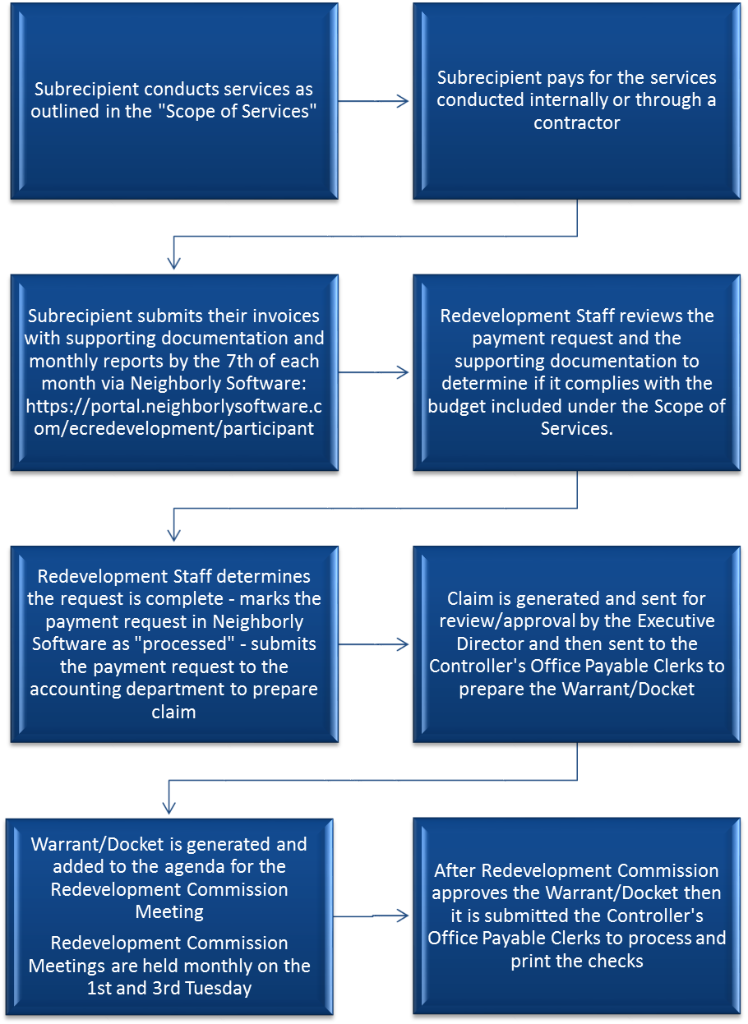
Please Note: It can take 3-5 business days for checks to be printed and mailed out.

DOCUMENTATION AND REPORTING REQUIREMENTS
2 CFR PART 200 AND 24 CFR PART 570 OVERVIEW AND DOCUMENTATION REQUIREMENTS
ELIGIBLE ACTIVITIES
NOTE: This is not an all-inclusive list of documentation, but rather the minimum standards for all programs. Depending on the program there may be additional required documentation.
CFR | CFR Category Title | Minimum Documentation Standards
24 CFR 570.200  24 CFR 570.208 | General Policies  Criteria for National Objectives | Program maintains adequate documentation to demonstrate:  - The area of service is in a low to moderate income area census tract. An example would be a map of the census tract being served to show that at least 51% of the area is low to moderate income.  - 51% or more participants meet low/moderate income criteria. Program can verify income eligibility through copies of participant pay stubs, tax returns and government assistance or through self-certification from each participant. (Appendix A contains the self-certification Form)  - Participants meet presumed benefit criteria. Programs that exclusively serve any of the following individuals can presume that 51% or more of their participants are low to moderate income.  - Abused Children;  - Battered spouses;  - Elderly persons;  - Adults meeting the Bureau of the Census’ Current Population Reports definition of “severely disabled”’  - Homeless persons;  - Illiterate adults;  - Persons living with AIDS; and/or  - Migrant farm workers
24 CFR 570.201  24 CFR 570.202  24 CFR 570.203 | Basic Eligible Activities  Eligible Rehab & Preservation Activities  Special Economic Development Activities | CDBG funds can be utilized for many different uses. Below is a list of the most common categories CDBG funds are used for:  - Acquisition of Real Property  - Disposition  - Public Facilities and Improvements  - Clearance  - Public Services (Restricted to 15% of total funds dispersed to all agencies)  - Interim Assistance  - Relocation  - Privately-Owned Utilities  - Rehabilitation  - Construction of Housing  - Special Economic Development Activities  - Microenterprise Assistance  - Homeownership Assistance
CFR | CFR Category Title | Minimum Documentation Standards
24 CFR 570.207 | Ineligible Activities | CDBG funds, however, cannot be used for the following categories:  - Buildings or portions for the general conduct of government  - General government expenses  - Political activities  - Purchase of equipment  - Operating and maintenance expenses  - Income payments
*NOTE: Although a project may be eligible per the code of federal regulations, it may not be a priority or need for the City of East Chicago. In addition to a project being eligible it must also meet the identified needs listed in the Consolidated Plan.
ADMINISTRATION
CFR | CFR Category Title | Minimum Documentation Standards
2 CFR 200  24 CFR 570.502 | Applicability of Uniform Administrative Requirements | State, local government, Indian tribe, institution of higher education (IHE), or nonprofit organization must comply with applicable requirements and standards found in: 2 CFR §200, except that:  (1) Section 2 CFR §200.305 “Payment” is modified for lump sum drawdown for financing of property rehabilitation activities, in accordance with 24 CFR §570.513.  (2) Section 2 CFR §200.306 “Cost sharing or matching” does not apply.  (3) Section 2 CFR §200.307 “Program income” does not apply. Program income is governed by 24 CFR §570.504.  (4) Section 2 CFR §200.308 “Revisions of budget and program plans” does not apply.  (5) Section 2 CFR §200.311 “Real property” does not apply, except as provided in 24 CFR §570.200(j). Real property is governed by 24 CFR §570.505.  (6) Section 2 CFR §200.313 “Equipment” applies, except that when the equipment is sold, the proceeds shall be program income. Equipment not needed by the subrecipient for CDBG activities shall be transferred to the recipient for the CDBG program or shall be retained after compensating the recipient.  Subrecipients must keep adequate records that comply with the applicable requirements. The financial records that must be maintained include, but not limited to:  - A chart of accounts  - Source documentation that costs were eligible and paid (invoices, purchase orders, canceled checks, etc.)  - An inventory of real property  - Bank account records  - Records regarding revolving loan fund activities  - Drawdown Requests  - Payroll records and reports  - Documentation of other administrative costs charged  - Financial reports / Audit Files / Financial Correspondence
2 CFR 200.343  24 CFR 91  24 CFR 570.507 | Closeout  Consolidated Submissions  Reports | The City of East Chicago is required to submit numerous reports to the Federal government and may request information from programs to complete the reports. The information may include, but not limited to, MBE/WBE information, Section 3 information, Performance Measures/Outcomes achieved, financial audits and funds leveraged. The specific reports that will be required from each agency will be outlined in the Agreement between the Department of Redevelopment and the Subrecipient.
RECORD RETENTION AND GENERAL RECORDS
CFR | CFR Category Title | Minimum Documentation Standards
2 CFR 200.334  24 CFR 570.502  24 CFR 570.506 | Retention requirements for records  Administrative Requirements  Records to be Maintained | - The retention period for individual CDBG activities shall be the longer of 3 years after the expiration or termination of the subrecipient agreement under 24 CFR §570.503, or 3 years after the submission of the annual performance and evaluation report, as prescribed in §91.520 of this title, in which the specific activity is reported on for the final time;  - Records for individual activities subject to the reversion of assets provisions at §570.503(b)(7) or change of use provisions at §570.505 must be maintained for as long as those provisions continue to apply to the activity; and  - Records for individual activities for which there are outstanding loan balances, other receivables, or contingent liabilities must be retained until such receivables or liabilities have been satisfied.  The Type of Records to Maintain for an activity, project or program:  - Description of each project/program, location, amount of CDBG assistance budgeted, obligated and expended.  - Sources and uses of funds, including CDBG, and all others.  - Compliance with Eligibility and National Objectives under 570.208.  The Type of Records to Maintain for a Community Based Development Organization (CBDO)  - Evidence that CBDO’s meet designation requirements during the period when they are receiving an allocation of CDBG funds to undertake special activities.
TIMELY EXPENDITURE OF FUNDS
CFR | CFR Category Title | Minimum Documentation Standards
570.902 | Review to determine if CDBG-funded activities are being carried out in a timely manner | Prior to issuing the next year’s Entitlement grant, HUD performs an annual assessment of each grantee’s performance. One of the performance factors examined is the “timeliness” of program expenditures.  When a Grantee (Redevelopment) fails to show that the funds are being expended in a timely manner, HUD’s corrective action will consider the following:  - The likelihood that the Subrecipient will spend enough funds during the next program year to reduce the amount to an acceptable level; and  - The extent to which funds on hand have been obligated by the grantee and its subrecipients for specific activities.
NOTE: Subrecipients are encouraged to download the “CDBG Timeliness Bulletin” from HUD’s website for tips and recommendations to avoid or solve problems with timely use of funds.
http://archives.hud.gov/offices/cpd/library/cdbg-bull.pdf

***All subrecipients must also provide Redevelopment with their annual financial audit for review***

MONITORING

OVERVIEW
In pursuant of the regulations at 2 CFR §200.332, the City of East Chicago Department of Redevelopment (REDEVELOPMENT) is responsible for managing the day-to-day operations of grant and subgrant supported activities. REDEVELOPMENT must monitor grant and subgrant supported activities to assure compliance with applicable Federal requirements and that performance goals are being achieved. The monitoring must cover each program, function or activity.

Monitoring is used to evaluate performance and compliance of subrecipients funded with the U.S. Department of Housing and Urban Development’s (HUD) Community Development Block Grant (CDBG) and HOME Investment Partnerships Program (HOME). The primary monitoring objective is to ensure that Federal funds received are used only for approved activities and are administered according to all applicable statutory and regulatory requirements. This established monitoring approach provides an early indication of problems or potential problems in meeting applicable requirements.

All applicants who are awarded CDBG and/or HOME funds should understand that their organization is subject to the policies set forth in this document. It is not intended to provide a negative outcome on any one organization that is submitted, but to provide Redevelopment with a fair assessment of its potential risks, at all levels, of any project as required in 2 CFR §200.206 and §200.332. Monitoring by the Redevelopment is not just a regulatory process or a fact-finding mission but involves effective communication and cooperative, problem-solving relationships between REDEVELOPMENT and its SUBRECIPIENTS.

Monitoring is not an audit of the subrecipient, but rather is focused on the “program” that is CDBG and HOME. To achieve this monitoring objective, REDEVELOPMENT will use an interactive, ongoing process. This approach includes instructional training, ongoing technical assistance, site visits, monthly/quarterly reporting, and annual monitoring. REDEVELOPMENT promotes efficient and effective SUBRECIPIENT performance.

TYPES OF MONITORING

To achieve the stated objective, REDEVELOPMENT conducts thorough financial and programmatic monitoring. The monitoring process is designed to incorporate a variety of monitoring techniques and tools into a coordinated effort, which ensures that all funded activities receive an appropriate level of review. The following types of monitoring techniques are incorporated into REDEVELOPMENT’S comprehensive approach.

- Individual Project Monitoring – Conducted as needed
This is the primary technique used for monitoring and reviewing funded activities implemented by its subrecipients. Regular contacts, as often as weekly or monthly may be required to deter potential issues and assure compliance with regulations.

- Desk Review – Conducted Monthly
This monitoring technique is used on a monthly basis and provides staff with an effective tool for examining ongoing project activities. Through this process, agencies are required to submit quarterly reports to identify ongoing activities. Redevelopment will analyze this information and make decisions regarding the need for additional technical assistance or future on-site visits. Desk reviews can also include an analysis of an agency’s accomplishments-to-date and rate of expenditures.

- On-Site Visits – Conducted Annually
At a minimum, at least one on-site visit will occur with each subrecipient. In certain situations additional visits will be conducted to discuss issues. When possible, a minimum of two weeks’ written notice will be given to a subrecipient prior to an on-site monitoring visit. The on-site visit will consist of interviews with key personnel as well as a review of pertinent records. The results of the monitoring visit will be placed in each file. A letter regarding the results of the monitoring will be sent to the Subrecipient’s Chief Official within 45 days. The letter will outline any concerns or findings and the necessary steps to take to remedy such matters. Any findings or concerns that are identified will require subsequent follow-up, either on-site or via correspondence and will be specifically addressed in the letter. If the subrecipient disagrees with the results of the monitoring, they will have 30 days to respond in writing.

- Davis-Bacon – Conducted as Needed
Construction projects requiring compliance with the Davis-Bacon Act will be monitored to assure payment of prevailing wage rates. Monitoring will involve on-site employee interviews. All contractors and subcontractors will submit employee payroll forms per HUD requirements, which will be reviewed for accuracy by Redevelopment. Labor relations compliance is also included within the scope of Davis-Bacon monitoring.

- Drawdown Requests – Conducted as Requests are Submitted
To assure the validity of requests to draw down funds, back up documentation is required with each request. The request must clearly describe the expenditures and should be reviewed for eligibility, consistency with approved project/program expenses, verification of remaining balance, proof of expense (i.e., invoice, timesheet, etc.), as well as compliance with the scope of work.

CLOSEOUT OF GRANT
The closeout of a grant is a process in which the City determines that all applicable administrative and program requirements of the applicable Grant Agreement between the City and the grantee have been completed.

In general, a project is ready for close-out when the following conditions are met:

- All activities have been completed and have met a national objective;
- All grant funds are expended in full or all remaining funds are to be recaptured by the City;
- All reporting requirements have been completed and submitted; and
- All audit and monitoring issues are resolved.

By signing the Grant Agreement, the SUBRECIPIENT agreed to the general and special conditions of the contract and to cooperate with any reviews, including making available records requested by the City of East Chicago Department of Redevelopment or any other duly authorized representative (e.g., HUD, Indiana State Board of Accounts, Office of the Inspector General, etc.)

TECHNICAL ASSISTANCE

Redevelopment staff will provide on-going technical assistance to any interested agencies both pre- and post-award.

APPENDIX A: SELF CERTIFICATION FORM / HUD INCOME LIMITS
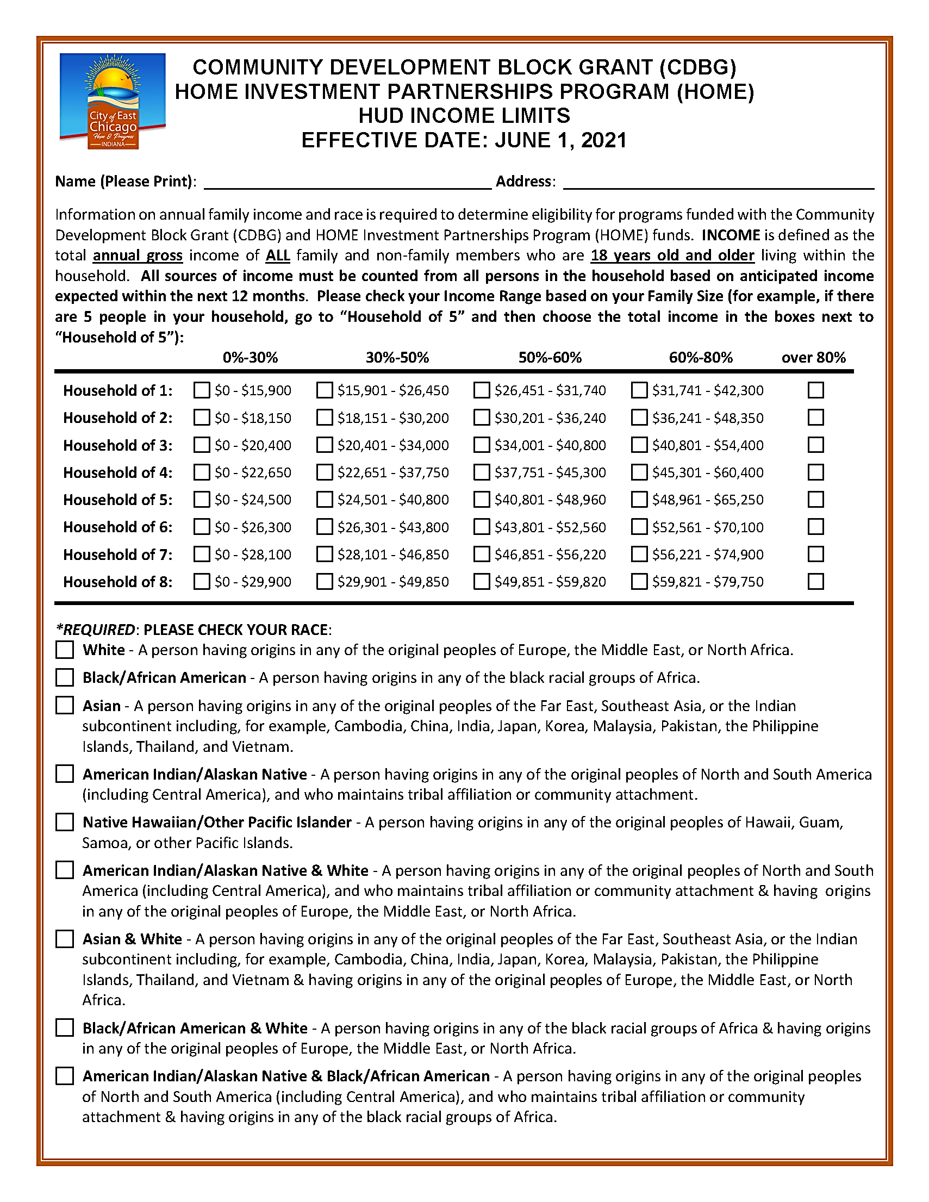

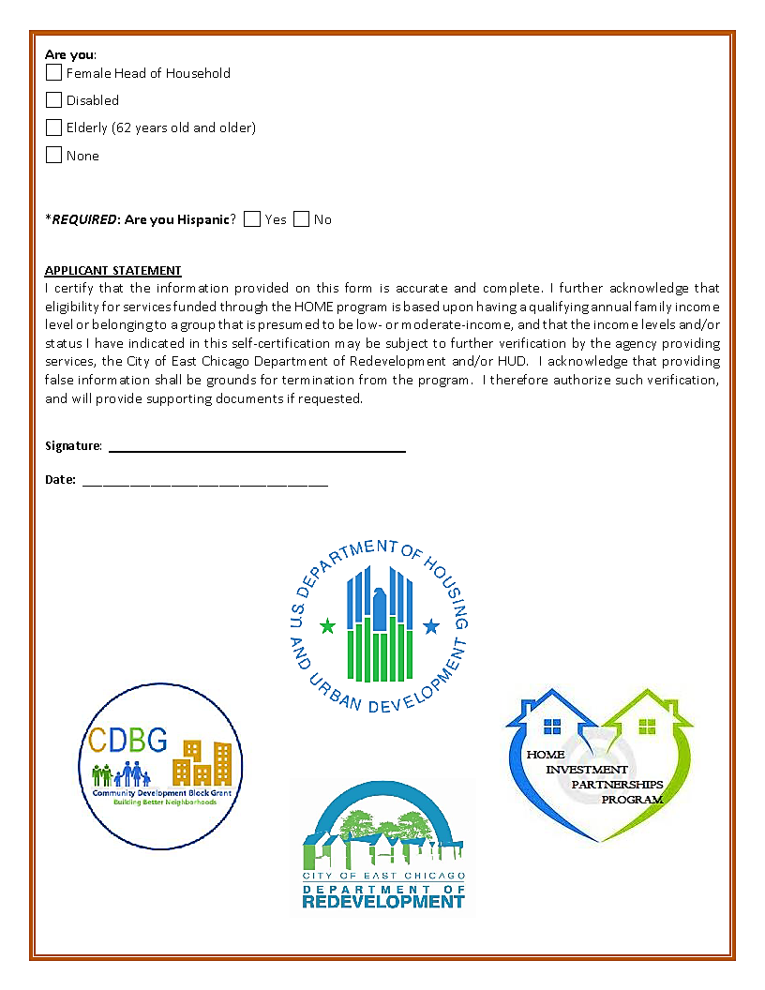

APPENDIX B: 2 CFR §200.112 CONFLICT OF INTEREST

Federal, State and City law prohibits employees and public officials of the City of East Chicago from participating on behalf of the City in any transaction in which they have a financial interest. The SUBRECIPIENT must disclose in writing any potential conflict of interest. Please answer the questions listed below.

- Are there any members of the applicant’s staff or any members of the Applicant’s Board of Directors or Governing Body who currently is or has/have been within one year of the date of this questionnaire (a) A City Employee [includes the Department of Redevelopment (ECDR)] or (b) A Board Member of the Redevelopment Commission or (c) A Member of the
City Council? Yes No

If yes, please list the name(s) below:

NAME | POSITION | AFFILIATION WITH CITY

- Will the City funds, requested by the applicant be used to award a subcontract to any individual(s) or business affiliate(s) who is/are currently or has/have been within one year of the date of this questionnaire a City employee (includes ECDR), consultant, member of the Redevelopment Commission or a member of the City Council? Yes No

If yes, please list the name(s) below:

NAME | POSITION | AFFILIATION WITH CITY

CONFLICT OF INTEREST QUESTIONNAIRE CONT’

- Are there any members of the applicant’s staff or members of the applicant’s Board of Directors of other governing body who are business partners or family members of a City employee (includes ECDR), consultant, member of Redevelopment Commission or a member of the City Council? Yes No

If yes, please list the name(s) below:

NAME | POSITION | AFFILIATION WITH CITY
If you have answered “Yes” to any questions listed on this Conflict of Interest Form, the Review Committee, along with Legal Counsel, will need to determine whether a real or apparent Conflict of Interest exists.

Name of Agency

Signature of Authorized Signing Official/Representative

Print Name of Authorized Signing Official/Representative

APPENDIX C: SUSPENSION AND DEBARMENT

The SUBRECIPIENT certifies by entering into this AGREEMENT that neither it nor its principals nor any of its subcontractors are presently debarred, suspended, proposed for debarment, declared ineligible or voluntarily excluded from entering into this Contract by (1) any federal agency, (2) any department, agency or political subdivision of the State of Indiana or (3) the City of East Chicago. The term “principal” for purposes of this Contract means an officer, director, owner, partner, key employee or other person with primary management or supervisory responsibilities, or a person who has a critical influence on or substantive control over the operations of the Contractor.
{NAME OF SUBRECIPIENT ORGANIZATION}

Printed Name Signature

Title Date

CITY OF EAST CHICAGO DEPARTMENT OF REDEVELOPMENT STAFF ONLY
 Please attach a copy of the debarment sheet from www.sam.gov
I certify that I have searched on www.sam.gov , printed out the results and attached to this contract.

Printed Name Signature

Title Date

APPENDIX D: E-VERIFY AFFIDAVIT


E-VERIFY AFFIDAVIT CONT’
DOCUMENTATION OF ENROLLMENT/PARTICIPATION
Please attach documentation for proof in enrollment/participation in the E-Verify Program
http://www.uscis.gov/e-verify/e-verify-enrollment-page

Indiana Code (IC) 22-5-1.7-11(b) requires that:
A state agency or political subdivision may not award a grant of more than one thousand dollars ($1,000) to a business entity unless the business entity:
(1) signs a sworn affidavit that affirms that the business entity
has enrolled and is participating in the E-Verify program;
(2) provides documentation to the state agency or political
subdivision that the business entity has enrolled and is
participating in the E-Verify program; and
(3) signs an affidavit affirming that the business entity does not
knowingly employ an unauthorized alien.

How E-Verify Works
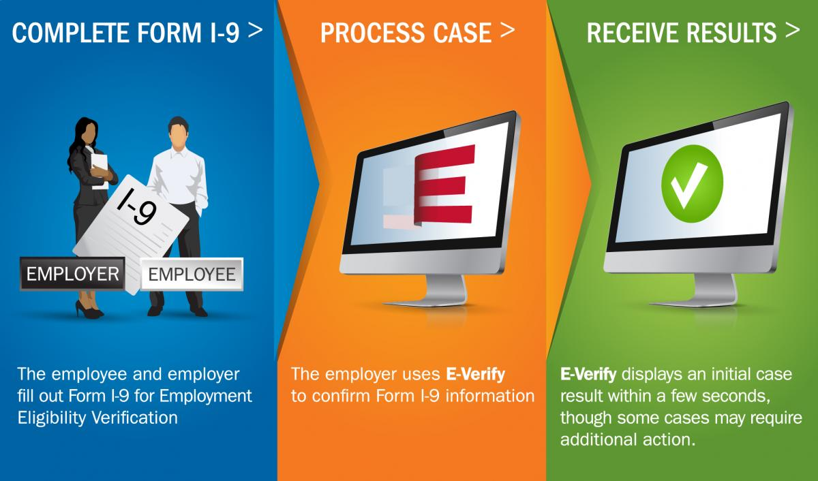

APPENDIX E: RESOLUTION NO. 2013-04
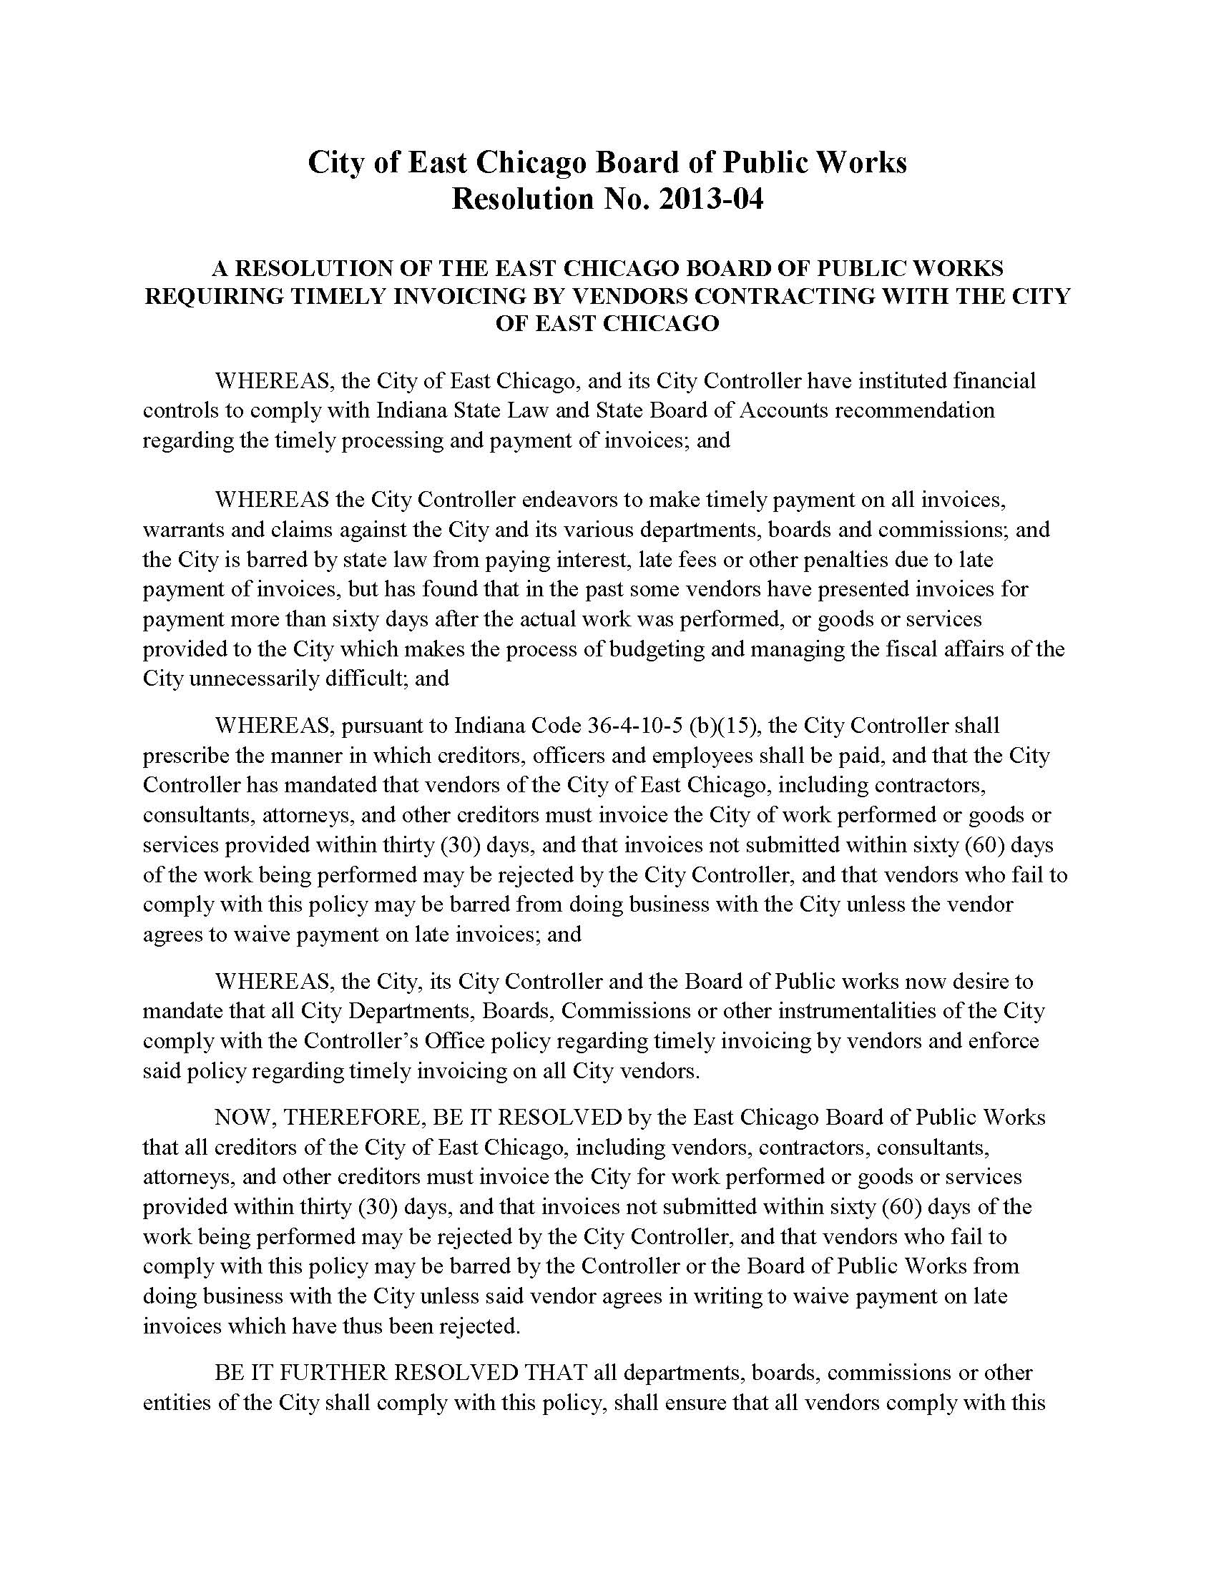

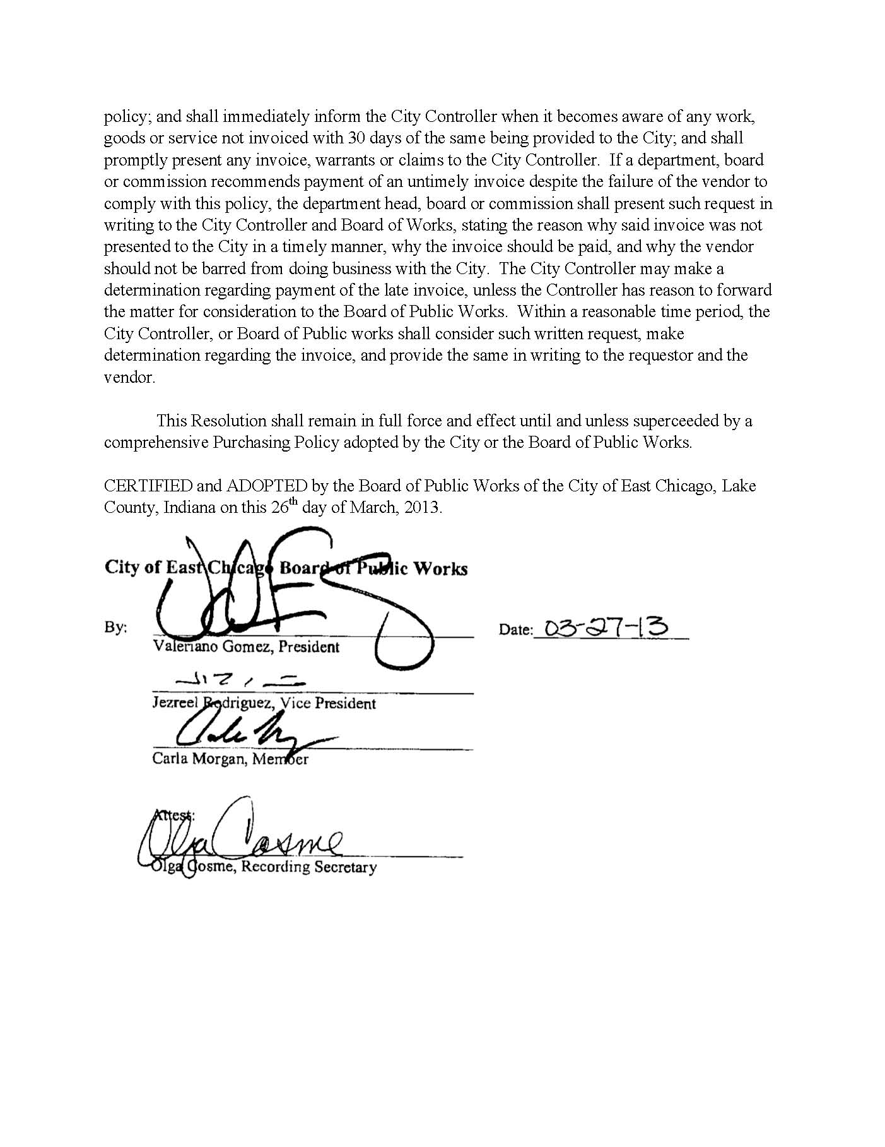

APPENDIX F: BUSINESS ENTITY REPORT
https://inbiz.in.gov/business-filings/business-entityreport

Businesses are required to file a report every other year to maintain active status. The business information is maintained by the state and provided to the public. Business Entity Reports are due every other year at the end of the month of the entity’s formation.

If you want to find out specifically when your business entity report is due, please conduct a Business Search at http://bsd.sos.in.gov/publicbusinesssearch. Locate your business in the search results, and click the Business ID link to be taken to the Business Details page where the Business Entity Report Due Date will be listed.

