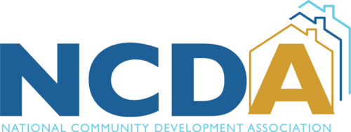
PRESS RELEASE

NCDA Installs New Executive Officers; Marcy Esbjerg (Pasco County, FL) to Serve as NCDA President

For immediate release

Washington, DC –

The National Community Development Association (NCDA), the premier membership organization for local government community development professionals, is pleased to announce the selection of Marcy Esbjerg, Pasco County, FL, as its new President and the following members as executive officers for 2024-2025. The election of officers took place at the NCDA 55th annual business meeting on June 14, 2024, in Cambridge, MA.

2024/2025 NCDA Executive Committee
Marcy Esbjerg, Pasco County, FL., President
David Bachrach, East Providence, RI., Vice-President
Angela Rahman, Kettering, OH., Secretary
Kevin Howard, Little Rock, AR., Treasurer

Marcy Esbjerg serves as the Director of Pasco County’s Community Development Department. She oversees the homeless initiatives, neighborhood revitalization, affordable housing opportunities and community partnerships implemented with federal and state grants. Arriving in Pasco in 2018, she brought with her 22 years of experience working with other Entitlement communities including Burlington, Vermont and Collier County, Florida.
Marcy joined NCDA in 2007 and has served as the Co-Chair of the Housing Committee and currently as the Co-Chair of the Membership Committee. She also serves on the Program and Planning Development Committee and has been on the Executive Committee for the past 3 years. She frequently shares best practices on housing, homelessness and community development initiatives during annual and legislative conferences.
“NCDA has been a key factor in my professional career. The training I have received along with the networking and relationships I have built have helped me to deliver quality programs in the County. It is both an honor and privilege to serve NCDA and its members and give back.”
“The experienced leadership of the Executive Committee and our new President, Marcy Esbjerg, will serve NCDA well. I look forward to working with them in the year ahead to advance NCDA’s strategic priorities.”

National Community Development Association (NCDA)
NCDA is a national association that represents local government departments across the country that administer federally supported community development and affordable housing programs. NCDA members administer HUD Office of Community Planning and Development (CPD) programs – CDBG, HOME, Homeless Assistance Grants, and HOPWA. Since 1969, NCDA has been at the forefront in securing federal resources and designing effective and responsive housing and community development programs for local governments. NCDA is an association of people committed to assisting local governments achieve high quality, locally responsive programs for making communities better places in which to live and work, particularly for low- and moderate-income people.

